**Andhra Pradesh**

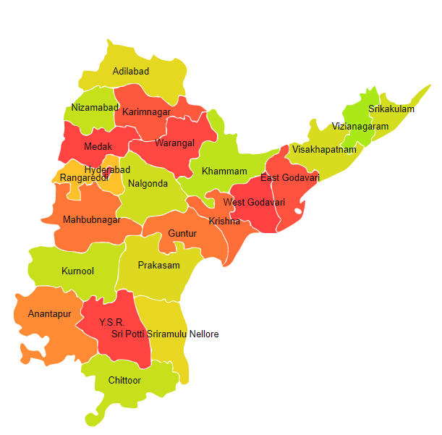

Andhra Pradesh comprises of five Agro Ecological Regions (AER) namely 3, 7, 8, 12 and 18.

**Agro-Eco Region 3 :** AER 3 in Andhra Pradesh comprises of Ananthapur district of Deccan Plateau under Agro Ecological Sub Region (AESR) 3.

**Agro-Eco Region 7 :** AER 7 in Andhra Pradesh comprises of Cuddapah, Guntur, Krishna, Kurnool, Nellore, Prakasam and West Godavari districts of Deccan (Telangana) Plateau and Eastern Ghats under Agro Ecological Sub Regions (AESR) 7.1 & 7.3.

**Agro-Eco Region8 :** AER 8 in Andhra Pradesh comprises of Chittoor district of Eastern Ghats under Agro Ecological Sub Region (AESR) 8.3.

**Agro-Eco Region 12 :** AER 12 in Andhra Pradesh comprises of East Godavari district of Eastern (Chhotanagpnr) Plateau and Eastern Ghats under Agro Ecological Sub Region (AESR) 12.1.

**Agro-Eco Region 18 :** AER 18 in Andhra Pradesh comprises of East Godavari, Krishna, Nellore, Prakasam, Srikakulam ,Vishakhapatnam, Vizianagaram and West Godavari districts of Eastern Coastal Plain under Agro Ecological Sub Regions (AESR) 18.3 and 18.4.

**Major NRM issues :**

**AESR 3 :** The region hot arid ESR with deep loamy and clayey mixed Red and Black soils, low to medium AWC and LGP 60-90 days in a year.

|  |  |  |  |  |
| --- | --- | --- | --- | --- |
| **Districts** | ***Land degradation*** | ***Soil health & fertility*** | ***Water related constraints*** | ***Environmental constraints*** |
| Ananthapur | Exclusively water erosion | Low in OC, Soil Deficient in N, Fe & B | Rainfed (> 40%), GW Saline, Contaminated with F & NO3 | Moderately prone to drought & Flood |

**AESR 7.1 :** The region hot dry semi-arid ESR with deep loamy to clayey mixed Red and Black soils, medium AWC and LGP 90-120 days in a year.

|  |  |  |  |  |
| --- | --- | --- | --- | --- |
| **Districts** | ***Land degradation*** | ***Soil health & fertility*** | ***Water related constraints*** | ***Environmental constraints*** |
| Cuddapah | Exclusively water erosion | Low in OC | Rainfed (> 40%), GW Contaminated with Fe | Highly prone to Flood, Drought & Cyclone |
| Kurnool | Exclusively water erosion | Low in OC, Soil Deficient in Zn & N | Rainfed (> 40%), GW Saline , Contaminated with F, NO3, As & Fe | **-** |

**AESR 7.3 :** The region hot moist semi-arid/dry subhumid ESR with medium to deep, loamy to clayey mixed Red and Black soils, medium AWC and LGP 150-180 days in a year.

|  |  |  |  |  |
| --- | --- | --- | --- | --- |
| **Districts** | ***Land degradation*** | ***Soil health & fertility*** | ***Water related constraints*** | ***Environmental constraints*** |
| Guntur | Exclusively water erosion, Coastal Salinity | Low in OC , Soil deficient in Zn & B | Rainfed (> 40%), GW Saline, Contaminated with F, NO3, As & Fe | Highly prone to drought, Flood & cyclone |
| Krishna | Exclusively water erosion ,Waterlogged & Coastal Salinity | Low in OC | Rainfed (> 40%), GW Saline, Contaminated with F, NO3 & Fe | Highly prone to drought, Flood & cyclone |
| Nellore | Exclusively water erosion , Waterlogged & Coastal Salinity | Low in OC, Soil deficient in Zn & Fe | Rainfed (> 40%), GW Saline, Contaminated with F, NO3, As, Fe | Highly prone to drought, Flood & cyclone |
| Prakasam | Exclusively water erosion , Waterlogged & Coastal Salinity | Low in OC , Soil deficient in Zn, Fe & B | Rainfed (> 40%), GW Saline, Contaminated with F, NO3 & Fe | **-** |
| West Godavari | Exclusively water erosion , Waterlogged & Coastal Salinity | Low in OC, Soil deficient in B &S | Rainfed (> 40%), GW Saline, Contaminated with F & NO3 | Highly prone to drought, Flood & cyclone |

**AESR 8.3 :** The region is hot moist semi-arid ESR with deep red loamy soils, low AWC and LGP 120-150 days in a year.

|  |  |  |  |  |
| --- | --- | --- | --- | --- |
| **Districts** | ***Land degradation*** | ***Soil health & fertility*** | ***Water related constraints*** | ***Environmental constraints*** |
| Chittoor | Exclusively water erosion , Waterlogged & Coastal Salinity | Soil Deficient in N | Rainfed (> 40%), GW Saline, Contaminated with F, NO3 & Fe | Severe Drought |

**AESR 12.1 :** The region hot moist subhumid ESR with deep loamy Red and Lateritic soils, low to medium AWC and LGP 180-210 days in a year.

|  |  |  |  |  |
| --- | --- | --- | --- | --- |
| **Districts** | ***Land degradation*** | ***Soil health & fertility*** | ***Water related constraints*** | ***Environmental constraints*** |
| East Godavari | Exclusively water erosion , Waterlogged & Coastal Salinity | Soil Deficient in N | GW Saline, Contaminated with NO3 | **-** |

**AESR 18.3 :** The region clayey Coastal and Deltaic alluvium-derived soils, low to medium AWC and LGP 150-180 days in a year.

|  |  |  |  |  |
| --- | --- | --- | --- | --- |
| **Districts** | ***Land degradation*** | ***Soil health & fertility*** | ***Water related constraints*** | ***Environmental constraints*** |
| Krishna | Exclusively water erosion , Waterlogged & Coastal Salinity | Low in OC & Soil Deficient in N | Rainfed (> 40%), GW Saline, Contaminated with F, NO3 & Fe | Highly prone to drought, Flood & cyclone. |
| Nellore | Exclusively water erosion , Waterlogged & Coastal Salinity | Low in OC, Soil Deficient in Zn & Fe | Rainfed (> 40%), GW Saline, Contaminated with F, NO3, As & Fe | Highly prone to drought, Flood & cyclone. |
| Prakasam | Exclusively water erosion , Waterlogged & Coastal Salinity | Low in OC, Soil Deficient in S , Zn, Fe & N | Rainfed (> 40%), GW Saline, Contaminated with F & NO3 | **-** |
| West Godavari | Exclusively water erosion , Waterlogged & Coastal Salinity | Soil Deficient in S & B | Rainfed (> 40%), GW Saline, Contaminated with F & NO3 | Highly prone to drought, Flood & cyclone. |

**AESR 18.4 :** The region hot dry subhumid ESR with deep, loamy to clayey Coastal and deltaic alluvium derived soils, medium AWC and LGP 180-210 days in a year.

|  |  |  |  |  |
| --- | --- | --- | --- | --- |
| **Districts** | ***Land degradation*** | ***Soil health & fertility*** | ***Water related constraints*** | ***Environmental constraints*** |
| East Godavari | Exclusively water erosion , Waterlogged & Coastal Salinity | Soil Deficient in N | Rainfed (> 40%), GW Saline, Contaminated with NO3 | **-** |
| Srikakulam | Exclusively water erosion , Waterlogged & Coastal Salinity | Low in OC, Soil Deficient in Zn & B | Rainfed (> 40%), GW Saline, Contaminated with F, NO3 & Fe | Moderately prone to drought, Flood & cyclone |
| Vishakhapatnam | Exclusively water erosion , Coastal Salinity | Low in OC | Rainfed (> 40%), GW Saline, Contaminated with F & NO3 | Moderately prone to drought, Flood & cyclone |
| Vizianagaram | Exclusively water erosion | Low in OC, Soil Deficient in Zn & B | Rainfed (> 40%), GW Contaminated with F & NO3 | Highly prone to drought & cyclone |

**Organization and Establishments for Technology Backstopping**

***SAUs/CAUs:***

|  |  |
| --- | --- |
| Acharya N.G. Ranga Agricultural University, Guntur | <https://angrau.ac.in/> |
| Dr. Y.S.R. Horticultural University, Venkataramannagudem, West Godavari | <http://www.drysrhu.edu.in/> |
| KVK Portal | <https://kvk.icar.gov.in/> |

***List of KVKs:*** <https://icar.org.in/content/andhra-pradesh-1>

***List of Soil testing Laboratories****:* <https://farmer.gov.in/STLDetails.aspx?State=28>